**INFOSYS SPRINGBOARD**

**5.0 INTERNSHIP**

STREAM:-

**COMPUTER SCIENCE AND ENGINEERING**

**PROJECT :-**

**FINANCIAL FORECASTING USING POWER BI**

*Submitted by*

**SAGAR K A**



**ACKNOWLEDGEMENT**

I would like to sincerely thank Infosys Springboard for providing me with the opportunity to participate in this internship, where I had the chance to explore the fascinating field of financial forecasting using Power BI Desktop.

I am deeply grateful to my mentor for their exceptional support, guidance, and valuable insights throughout this project. Their expertise and feedback have had a significant impact on the overall quality and scope of my work.

I also want to extend my thanks to the entire Infosys Springboard team for creating an internship program that promotes hands-on learning and the practical application of knowledge. This experience has allowed me to enhance my technical abilities and expand my understanding of data analysis, skills that will be invaluable in my professional journey.

Finally, I would like to express my appreciation to my family, friends, and peers for their unwavering encouragement and belief in me. Their support has been an incredible source of motivation.

This report represents a collective effort, and I am truly thankful to everyone who contributed to its successful completion.

**ABSTRACT**

Financial forecasting plays a pivotal role in business decision-making, enabling organizations to predict future financial performance, optimize resource distribution, and support strategic planning. This project aims to create an interactive financial forecasting dashboard using Power BI, a versatile data visualization tool. The primary objective was to convert historical financial data into valuable insights through dynamic visual representations, empowering decision-makers to make informed, data-driven choices.

The project entailed the gathering and preprocessing of financial data, the application of forecasting techniques like moving averages and exponential smoothing, and the utilization of DAX (Data Analysis Expressions) for real-time data analysis. The dashboard features an intuitive interface for stakeholders to examine financial trends, forecast future outcomes, and evaluate crucial financial indicators such as revenue, expenditures, and profit margins.

By incorporating advanced forecasting models into Power BI, this project highlights the effectiveness of data visualization tools in enhancing business intelligence, optimizing financial forecasting, and aiding strategic decision-making. The report outlines the methodologies used, challenges faced, and results achieved, providing a thorough overview of how modern business intelligence platforms can streamline financial forecasting.

**SCOPE OF THE PROJECT**

This project aims to develop an interactive financial forecasting dashboard using Power BI, covering all stages from data collection and preprocessing to final visualization and reporting. It involves the complete data analysis lifecycle, which includes:

* Gathering and preparing financial data.
* Applying forecasting models to predict future financial outcomes.
* Utilizing Power BI for data transformation, modeling, and visualization.
* Designing a user-friendly dashboard that enables stakeholders to interact with the data, explore trends, and make informed decisions.
* Using DAX for real-time calculations and advanced data analysis.

The project also includes integrating Power BI with existing business processes to deliver insights that aid in strategic decision-making.

**OBJECTIVE**

The primary objective of the project is to develop an interactive financial forecasting dashboard using Power BI to facilitate data-driven financial planning. The specific objectives are:

● To transform historical financial data into meaningful insights using dynamic visualizations.

● To implement advanced forecasting techniques for predicting future financial outcomes.

● To design an intuitive and interactive dashboard that allows users to analyze financial trends and make informed decisions.

● To improve financial planning by providing stakeholders with real-time updates and performance analysis of key metrics such as revenue, expenses, and profit margins.

**METHODOLOGY**

The methodology of this project involves a systematic approach to data collection, processing, analysis, and visualization:

1. **Data Collection:** Financial data from relevant sources is collected and imported into Power BI from Excel, CSV, or online databases.

2. **Data Preprocessing:** The raw data is cleaned and transformed using Power Query to ensure consistency and relevance. This includes removing duplicates, handling missing values, and standardizing formats.

3. **Data Modeling:** Relationships between different data tables are defined, and DAX (Data Analysis Expressions) is used to create calculated columns and measures.

4. **Forecasting Techniques:** The project applies forecasting techniques such as moving averages and exponential smoothing to predict future financial performance.

5. **Dashboard Design:** An interactive Power BI dashboard is developed to display the financial data and forecasts, incorporating visualizations like bar charts, line graphs, and tables.

6. **Interactivity:** Filters, slicers, and cross-filtering options are added to enable users to interact with the data and focus on specific insights.

7. **Publishing and Sharing:** Once the dashboard is complete, it is published to the Power BI service for online sharing, collaboration, and real-time updates

**INTRODUCTION TO POWER BI**

**Power BI Definition**

Power BI is a tool created by Microsoft that helps you turn raw data into meaningful visuals like charts, graphs, and dashboards. It allows you to easily analyze and understand your data, share reports with others, and make informed decisions based on the insights you get. It’s like a smart assistant for your data that helps you In today's data-driven world, businesses rely heavily on tools that provide insights and enhance decision-making processes. Microsoft Power BI, a business intelligence tool, stands out for its ability to clean, analyze, and transform data into actionable visual formats. With its wide array of features, Power BI empowers organizations to make informed decisions quickly and efficiently. This paper provides an in-depth understanding of Power BI, focusing on its core components, data modeling, dataset modes, and its practical applications in various industries.

**Components of Power BI**

1. **Power Query**

○ A data transformation and preparation tool that allows users to clean, shape, and combine data from various sources.

○ Example: Removing duplicates, merging datasets, or transforming columns. 2. **Power Pivot**

○ A data modeling tool used for creating relationships between tables, performing calculations, and building data models using DAX (Data Analysis Expressions). ○ Example: Summing sales revenue or calculating profit margin.

3. **Power View**

○ A visualization tool for creating interactive charts, graphs, and maps to present data in an engaging way.

○ Example: Creating sales trend line graphs or customer demographic pie charts. 4. **Power BI Service**

○ A cloud-based platform for sharing, collaborating, and publishing Power BI reports and dashboards.

○ Example: Hosting reports for team access and setting up scheduled data refresh.

**STEPS IN POWER BI**

**Step 1: Loading Data**

**Description:**

● The first step in Power BI involves importing data from various sources such as Excel, CSV, SQL Server, or online services.

● Power BI allows you to preview the data and select specific tables or fields before loading.

● After loading, data is stored in Power BI for further processing and analysis.

**Key Features:**

● Connect to multiple data sources.

● Combine data from different files or databases.

**Step 2: Transforming Data (Power Query)**

**Description:**

● Transformation is performed in Power Query, where raw data is cleaned and prepared for analysis. ● You can modify, filter, and shape your data to ensure consistency and relevance.

● Common tasks include renaming columns, removing null values, and changing data types. **Key Features:**

● Filter rows based on conditions.

● Merge and append queries to combine datasets.

● Add calculated columns or split data into new columns.

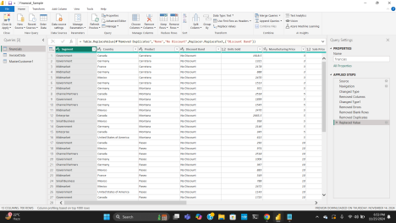

**Step 3: Data Preprocessing**

**Description:**

● Preprocessing ensures the data is clean, standardized, and ready for use.

● It addresses missing values, duplicates, and inconsistencies to improve the quality of insights. **Key Features:**

● Remove duplicates to avoid errors in analysis.

● Handle missing data by filling, replacing, or removing nulls.

● Standardize formats for consistency, such as date formats and numeric precision.

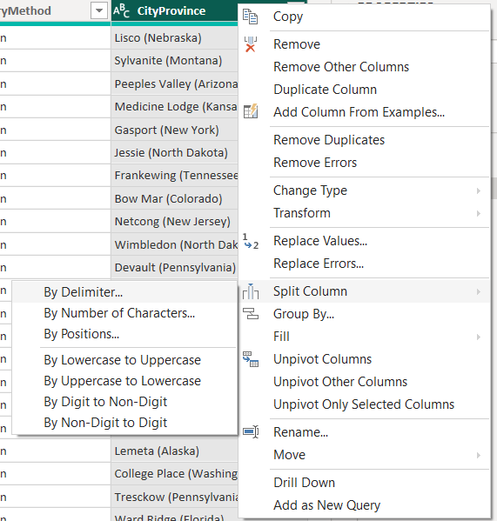

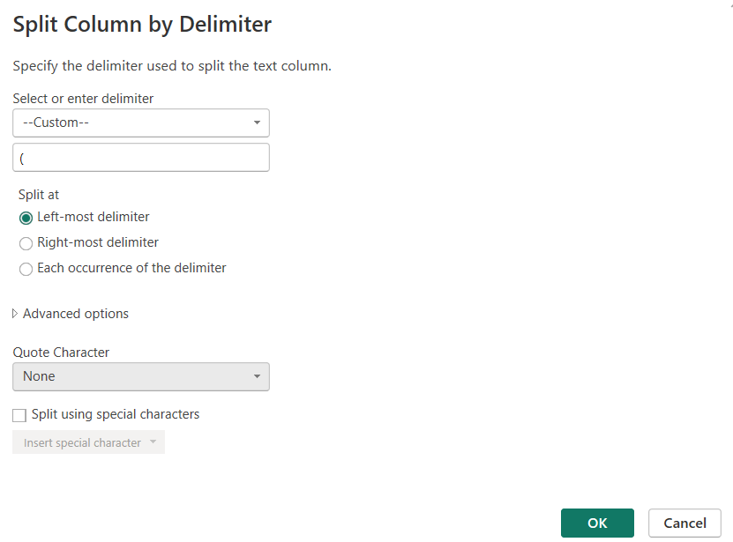

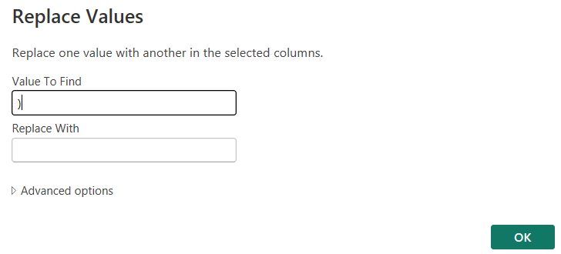

**Step 4: Data Modeling**

**Description:**

● Data modeling involves creating relationships between tables, defining measures, and building hierarchies.

● Proper modeling ensures efficient data analysis and seamless visualizations.

● Relationships define how data in different tables interacts.

**Key Features:**

● One-to-one, one-to-many, or many-to-many relationships.

● DAX (Data Analysis Expressions) for calculated columns and measures.

● Define hierarchies for drill-down functionality.

**Step 5: Visualization**

**Description:**

● Power BI provides an interactive canvas for creating visuals, charts, and dashboards. ● Users can choose from a variety of visualizations like bar charts, line graphs, tables, and maps to represent their data.

● Visuals can be customized to enhance clarity and user engagement.

**Key Features:**

● Drag-and-drop functionality for creating visuals.

● Interactivity using slicers and filters.

● Customization of colors, labels, and layouts.

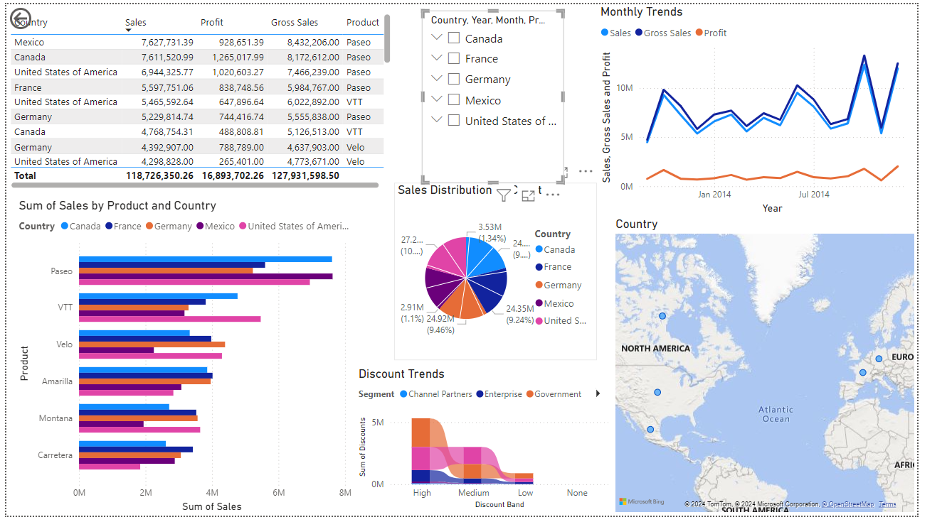

**Step 6: Adding Filters and Slicers**

**Description:**

● Filters and slicers enable users to narrow down data and focus on specific insights dynamically. ● They improve report interactivity and allow deeper exploration of data.

**Key Features:**

● Report-level, page-level, or visual-level filters.

● Slicers for date ranges, categories, or specific fields.

● Cross-filtering between visuals.

**Step 7: Publishing and Sharing**

**Description:**

● Once the report is complete, it can be published to the Power BI Service for sharing and collaboration. ● Published reports are accessible online and can be embedded in apps or websites. ● Sharing ensures stakeholders can interact with the dashboards.

**Key Features:**

● Publish reports to the Power BI Service.

● Schedule data refresh for up-to-date insights.

● Export dashboards to other formats like PDF or PowerPoint.

**FEATURES**

### Data Connectivity in Power BI

Power BI supports data connectivity with over 100 sources, ranging from structured databases to unstructured data repositories. Users can import data or connect live to data sources. This flexibility enhances Power BI’s usability across diverse business environments.

### Export Options in Power BI

Power BI supports exporting reports and dashboards in various formats, including PDF, PowerPoint, CSV, PNG, Excel, and PBIX. These export options ensure compatibility with other tools and platforms, making Power BI a versatile solution for data sharing and reporting.

### Power BI Desktop and Power BI Service

Power BI Desktop and Power BI Service are complementary tools designed for different aspects of business intelligence.

#### Power BI Desktop

* Development Tool: Power BI Desktop is primarily used for creating dashboards and reports.
* Components: It integrates Power Query, Power Pivot, and Power View, providing a comprehensive development environment.
* Publishing: Reports created in Desktop can be published to Power BI Service for broader access.

#### Power BI Service

* Cloud Platform: Power BI Service is the cloud-based counterpart of Power BI Desktop.
* Sharing: It enables users to share and collaborate on reports and dashboards in real-time.

### Data Modeling in Power BI

Data modeling involves creating a logical structure to facilitate data analysis and reporting.

#### Relationships

Relationships define how data in one table relates to another. Power BI supports three types of relationships:

* One-to-Many (1-N): A single record in one table corresponds to multiple records in another table.
* Many-to-One (N-1): Multiple records in one table correspond to a single record in another.
* One-to-One (1-1): Each record in one table corresponds to a single record in another table.

**Snapshots:**

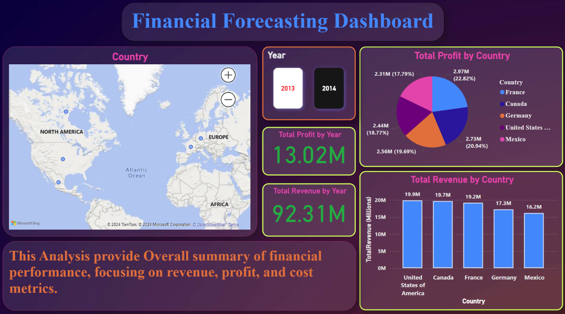

**Fig: Overview of Financial Dashboard**

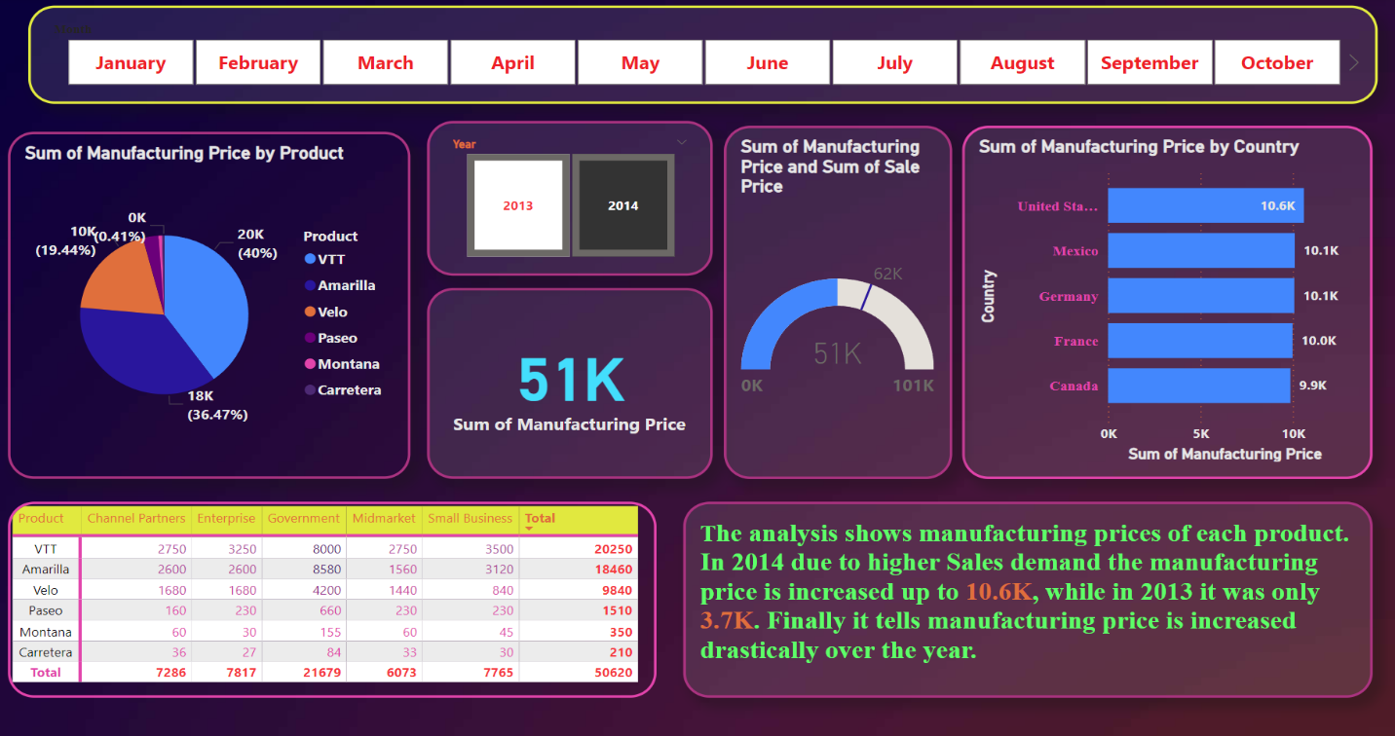

**Fig: Manufacturing details can be analyzed.**

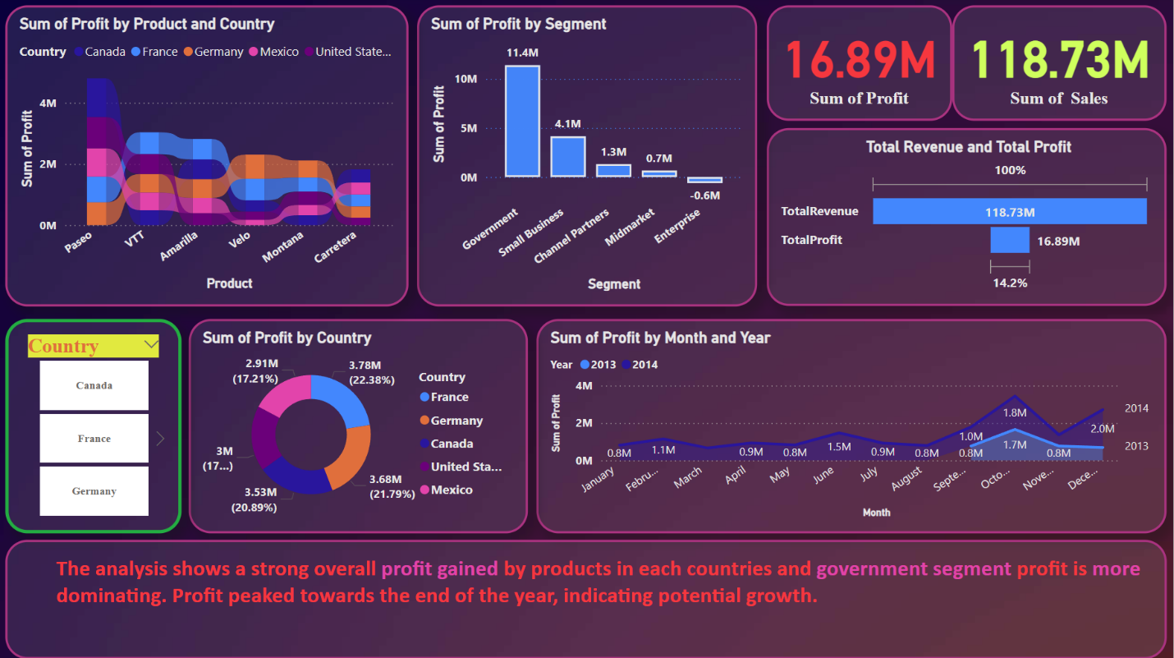

**Fig: This Dashboard shows overall profit analysis**

**Conclusion**

This project effectively showcases the potential of Power BI in creating an interactive financial forecasting dashboard, a valuable tool for enhancing data-driven decision-making in financial planning. By converting raw financial data into meaningful visualizations, the dashboard empowers stakeholders to assess trends, forecast future financial performance, and optimize resource allocation.

Through the use of advanced forecasting methods such as moving averages and exponential smoothing, the project accurately predicts key financial metrics, including revenue, expenses, and profit margins. The integration of Power BI’s features, such as DAX for real-time calculations and dynamic data interactivity, enables users to explore data, conduct detailed analysis, and make informed decisions based on the most current insights.

Additionally, the project demonstrates Power BI’s strengths in data loading, transformation, modeling, and visualization, while also illustrating how interactive dashboards can simplify complex financial forecasting tasks. With its intuitive user interface, the dashboard allows users to engage with data more deeply, improving their ability to make strategic financial decisions.

In summary, this project highlights how modern business intelligence tools like Power BI can significantly enhance financial forecasting, optimize decision-making, and contribute to more effective financial planning within organizations. The skills and techniques applied here are not only valuable for business analytics but also serve as a foundation for future projects that integrate data science and visualization across various industries.

### **Core Components of Power BI**

Power BI comprises four main components: Power Query, Power Pivot, Power View, and Power BI Service. Each plays a distinct role in the data analysis lifecycle, contributing to the overall effectiveness of the tool.

#### **1. Power Query**

Power Query serves as an ETL (Extract, Transform, Load) tool within Power BI. It extracts data from various sources, transforms it by cleaning and organizing, and loads it into the Power BI workspace.

* **Extract**: Data can be sourced from structured, semi-structured, and unstructured data repositories.
* **Transform**: Transformation involves cleaning data, such as handling missing values and standardizing formats.
* **Load**: The cleaned data is loaded into the Power BI workspace for further analysis.

Power Query’s intuitive interface allows users to handle complex data transformations without requiring advanced programming knowledge.

#### **2. Power Pivot**

Power Pivot is used for data modeling, especially when integrating multiple data sources. It enables the creation of relationships between tables, facilitating data analysis across interconnected datasets.

* **Data Modeling**: Power Pivot provides a foundation for logical data structuring, enabling the seamless merging of data from different tables.
* **Relationships**: Relationships help connect tables, allowing users to perform calculations and build meaningful visualizations using data from multiple sources.

#### **3. Power View**

Power View is the visualization engine of Power BI, offering over 250 visual types, including line charts, bar charts, pie charts, and KPI charts.

* **Interactive Dashboards**: Users can create dynamic dashboards that allow real-time data exploration.
* **Custom Visuals**: Power BI supports third-party visuals, extending the tool’s flexibility.

#### **4. Power BI Service**

The Power BI Service is a cloud-based platform that enables sharing and collaboration. Reports and dashboards created in Power BI Desktop can be published to the Service, making them accessible to stakeholders.

* **Collaboration**: Users can collaborate with clients, colleagues, and end-users via shared reports.
* **Accessibility**: Power BI Service ensures secure access across devices, including mobile applications.

### **Data Connectivity in Power BI**

Power BI supports data connectivity with over 100 sources, ranging from structured databases to unstructured data repositories. Users can import data or connect live to data sources. This flexibility enhances Power BI’s usability across diverse business environments.

### **Export Options in Power BI**

Power BI supports exporting reports and dashboards in various formats, including PDF, PowerPoint, CSV, PNG, Excel, and PBIX. These export options ensure compatibility with other tools and platforms, making Power BI a versatile solution for data sharing and reporting.

### 

### 

### **Power BI Desktop and Power BI Service**

Power BI Desktop and Power BI Service are complementary tools designed for different aspects of business intelligence.

#### **Power BI Desktop**

* **Development Tool**: Power BI Desktop is primarily used for creating dashboards and reports.
* **Components**: It integrates Power Query, Power Pivot, and Power View, providing a comprehensive development environment.
* **Publishing**: Reports created in Desktop can be published to Power BI Service for broader access.

#### **Power BI Service**

* **Cloud Platform**: Power BI Service is the cloud-based counterpart of Power BI Desktop.
* **Sharing**: It enables users to share and collaborate on reports and dashboards in real-time.

### **Data Modeling in Power BI**

Data modeling involves creating a logical structure to facilitate data analysis and reporting.

#### **Relationships**

Relationships define how data in one table relates to another. Power BI supports three types of relationships:

* **One-to-Many (1-N)**: A single record in one table corresponds to multiple records in another table.
* **Many-to-One (N-1)**: Multiple records in one table correspond to a single record in another.
* **One-to-One (1-1)**: Each record in one table corresponds to a single record in another table.

#### **Model View**

The Model View in Power BI Desktop allows users to visually define relationships between tables. This visual representation simplifies the process of data modeling, even for non-technical users.

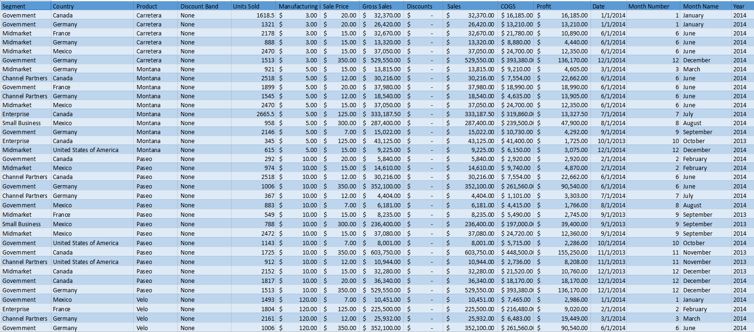

### 

### 

### 

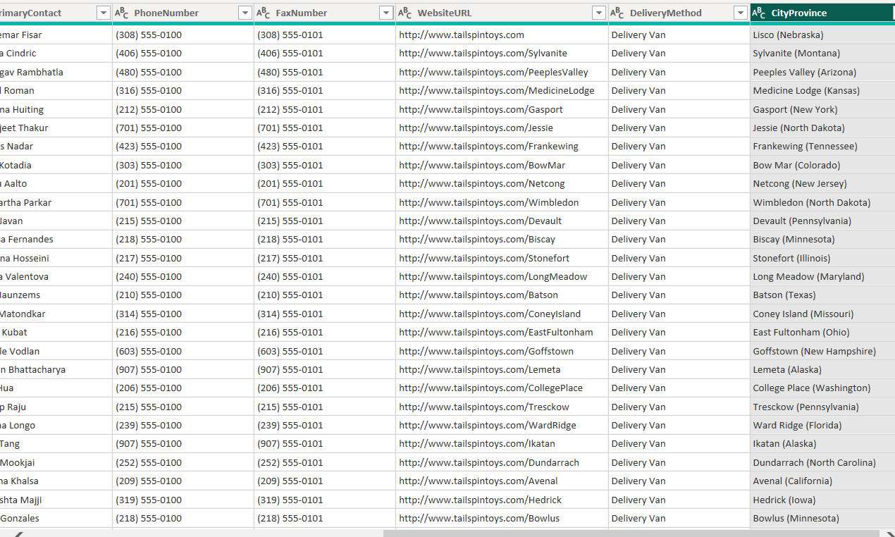







### **Dataset Modes in Power BI**

Power BI offers three dataset modes, each suited to specific use cases:

#### **1. Import Mode**

* **Efficiency**: Import Mode is faster for smaller datasets.
* **Data Storage**: Data is imported and stored within the Power BI environment.
* **Use Case**: Best for static datasets requiring high performance.

#### **2. Direct Query Mode**

* **Real-Time Data**: Direct Query connects to live data sources, ensuring real-time updates.
* **Large Datasets**: Suitable for larger datasets where importing is impractical.

#### **3. Composite Mode**

* **Flexibility**: Combines the features of Import and Direct Query modes.
* **Advanced Analytics**: Supports calculated tables and dual-mode data connections.

### **Data Analysis Expressions (DAX)**

DAX is a formula language in Power BI used for advanced calculations and data modeling.

* **Data Types**: DAX supports both numeric (decimals, currency) and non-numeric (strings, binary) data types.
* **Applications**: DAX is used for creating measures, calculated columns, and calculated tables.

DAX formulas enhance the analytical capabilities of Power BI, enabling users to uncover hidden patterns in data.

### **Views in Power BI**

Power BI provides various views to assess data quality and distribution:

* **Column Quality**: Indicates the validity and completeness of data.
* **Column Distribution**: Highlights unique and distinct values in a dataset.

### 

### **Advantages of Power BI**

Power BI offers numerous advantages, making it a preferred tool for business intelligence:

* **Accessibility**: Power BI Desktop is free and available on Microsoft Store.
* **Versatility**: It supports structured, semi-structured, and unstructured data.
* **Visualization**: A wide range of visual types enhances data presentation.
* **Mobile Compatibility**: Power BI Mobile ensures data access on the go.

### **Applications of Power BI**

Power BI is widely used across industries for:

* **Business Reporting**: Creating dynamic reports and dashboards.
* **Data Analysis**: Identifying trends and patterns in data.
* **Collaboration**: Sharing insights with teams and stakeholders.

### **Conclusion**

Power BI is a powerful tool that combines data connectivity, modeling, and visualization to provide actionable business insights. Its core components, flexible data handling capabilities, and collaborative features make it an indispensable asset for modern organizations. By leveraging Power BI, businesses can streamline their decision-making processes and maintain a competitive edge in an increasingly data-driven world.

**References**Microsoft. (n.d.). *Power BI documentation*. Retrieved from [<https://learn.microsoft.com/en-us/power-bi/>]  
Singh, A. (2023). *Mastering Power BI: A Comprehensive Guide*. Pearson Education.  
Jones, R. (2022). *Data Modeling with Power BI*. Wiley.